Areeb Hussain

Assylbek Bugybay

Lola Ueda



20. June 2022

RUBBER

DUCKY

Detecting “Bad USB” attacks (Part II)

Table of Contents

1. Target phone….……………………………………………………………….2

1.1 Emails forwarder keystrokes rubber ducky…………………………………….2

1. Target phone

Android is a touch-centric operating system, but when you connect a keyboard to your smartphone or tablet, it supports some keyboard shortcuts out of the box. They aren't going to remove the need to use the touchscreen, but they can be useful for some tasks. These extensions make it possible to access any application or repository and make possible rubber ducky attacks[1].

1.1 Emails forwarder keystrokes rubber ducky

The next code is the full code used to open the email and forward it to the external address.

Now let’s have a look step by a step changes in the phone’s UI after inserting certain commands.

**Initial photo:**

**Command:**



**Result:**

**Command:**

**Result:**

**Command:**

**Result:**

**Command:**

**Result:**

**Command:**



**Result:**

**Command:**



**Result:**

**Command:**

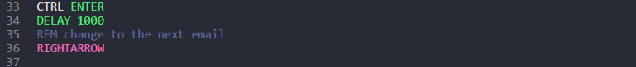

**Result:**

References

1. URL: https://defkey.com/android-bluetooth-shortcuts

[last accessed: 2022-06-20]